Lee's Lookout
31.877933° -106.500250° 5,520 MSL 1,000' AGL
LZ 31.910659° -106.519001° and 31.876146° -106.519084°
Bail LZ's: PG/HG 31.871923° -106.507787° PG only 31.882664° -106.507055°
WARNING: Pilots must have expert launching skills! Do not attempt to fly this site if you cannot safely launch from a 45-degree sloped postage-stamp!

Introduction
Lee's Lookout continues to be our best west-facing site for flying in the Franklin Mountains State Park. It is named after local pilot Lee Boone, the discoverer of the site. It is a vertical (12) minute hike from the Transmountain Pass highway (SR #375). As pilots will enter the Park, they must be registered and have paid the daily use fee (or have a Texas State Park pass). Here is the info for registration and passes, go here.
Lee's Lookout should be flown when: 1.) It is too weak to launch from Agave. 2.) Wind direction at Santa Teresa (the National Weather Service location in our region) is west to southwest (PG only). PG pilots should not launch if winds are northwest – the site is too small to safely inflate a glider with this wind direction. If winds at the surface are west/southwest and greater than 8-10, launch from Agave is much safer. HG pilots can launch in any direction. Lee's Lookout has the advantage of being just above the daily inversion which reaches about 5,000' MSL. It will have sufficient air to launch when Agave is calm. Its proximity to the Dragons Mouth (DM) ensures that any west component in the wind will be almost southwest at launch due to the strong vortex at DM which makes launch easier when conditions are weak everywhere else. Launch is tight (10 yd. x 10 yd.). If PG pilots walk down the steep slope some ways and lay their wing out near the edge, inflation is easier. The downside is that the pilot cannot see his lines until the glider comes up – someone helping can scan them. HG should not have any problems as the launch to north/right has a sheer cliff in front.
PG pilots should always launch to the left (facing almost south) and follow the ridge out. The stronger the conditions, the more the pilot will ascend immediately after launch. In weaker conditions, he may have to follow the ridge out and hunt for thermals – there are always plenty of them! Remember that the geography of Lee's Lookout ensures that winds at launch will be from the south (strong conditions) or southwest (weaker conditions) because of the vortex at DM. That is, if winds at Santa Teresa are west, the winds at launch will be southwest or south.
The northwest portion of the site can be very thermic due to its dark color and west face, even at the end of the day. But as the pilot is launching to the south (and left), it is safe to launch during a lull as the thermals moving up the northwest part of the site will not affect the air out in front to the left. When winds are west to southwest miles out front, the vortex of the DM causes the air to swirl around the ridge and up the northwest part of the launch area triggering thermals in the process. Accordingly, the air to the south or left will be smooth all the way out if, for example, it is late in the day. Otherwise, thermal strength out front will be the same as elsewhere in the range. The weaker the conditions, the less pronounced this effect is. This has been proven many times by actual flights from the site.

Expectations for student pilots
Students must be advanced in their P3 skills to launch from Lee’s Lookout.
Wind must be 240 degrees. Wind speed should be between 4-8 mph.
The site should not be flown outside of the normal 1.5 hours on either side of dusk and dawn because of the intense thermals that come roaring up the fingers out front.
Reverse launching is mandatory and the pilot must not turn until the glider is stable overhead for a few seconds. A blown launch is a serious matter here as there are numerous rocks and obstacles out front and a sheer cliff to the right of the launch area.
After launching, pilots may follow the finger out front all the way to the end. The end of the finger has house thermals which, at the beginning and end of the day, are relatively weak. If the pilot is successful in getting up, stay in front of the range and do not drift back. Always be alert to drifting or flying north at low altitude (same altitude as the Pass). Once up above the top of the peaks south of the Pass, head north for the Agave Hill LZ. If in doubt at any time, must head for the bail LZ for Lee’s Lookout.
If the pilot gets below the level of the finger out front, he should head out to the bail LZ in front (see below) and land. It may be a long walk to a road.
The main hazard of the site is to stay out of the canyon to the left of launch (easy to do) which has power lines coming up. Directly in front of the range there is also a power line so pilots must not land directly in front. The bail LZ is huge and easy to land in but there may be bushes which are a nuisance if they encounter a glider.

LZ Info
The main LZ is the area around the Tom Mays Park entrance 2.6 miles NW of launch. Park a vehicle just outside the entrance gate of Tom Mays Park and drive another to the top of the Pass. It is somewhat easier for PG pilots to land on the Tom Mays access road east of the gate as they can set up a mile away. As there are often thermals popping off everywhere around the roads, using the access road east of the gate allows for plenty of margin. The access road slopes down for a half a mile and is clear on both sides. HG pilots should land at the normal LZ for Agave Hill which is 6/10ths of a mile NE of the PG LZ.
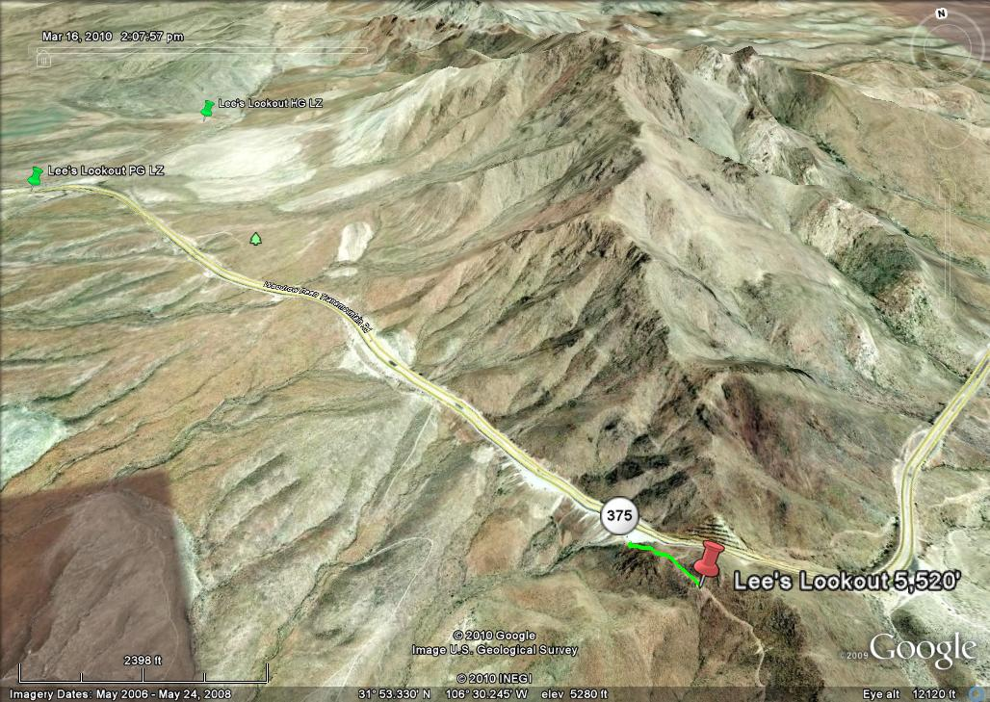
Landing in the desert is often more complicated than coastal or other inland sites because of the very hot ground at the surface (+140°F in the summer) which causes small but powerful thermals to pop off near the surface. They can dramatically change where you land.
The PG LZ near the entrance of Tom Mays Park. The access road faces SW and is a 1/2-mile-long so pilots can relax and setup without worry if they encounter thermals while landing.

Bail LZ Info
If you do a sled ride from launch, just follow the ridge straight out and then make a 90° turn either direction at the end (left for HG/PG or right for PG only). If you go left (south), head for the dirt road that goes from the top of the ridge down the canyon to a housing development. It is plenty long and slopes down at first and then becomes almost level near the housing development. If you go left, remember that it is at least (40) minute drive one way from the pass to pick you up so you must have a driver. To get to the HG/PG bail LZ from the Transmountain highway, go west down the hill for about (5) miles and turn left (south) on N. Resler. j Go 3.4 miles, turn left (east) on High Ridge drive and then go 1.9 miles to the end (at the time of this writing, there is some unimproved road at the end). Make a quick jag right and then left onto Calle Lago for 0.4 miles where there is a gate (it's a gated community). If it's open, you're in luck. If not, you will have to walk up and find your pilot somewhere.
If conditions at the DM are not too strong, PG pilots can fly out to the end of the ridge at launch, turn right (north), and cautiously go in front of the DM at low altitude (<5,000' MSL). Stay well in front of the DM and land on the top of the second finger ridge (past the most northwest of the picnic areas). It is an easy hike from the PG bail LZ to the highway and then to the top of the Pass. The second finger ridge has a road going down it so it is easy to spot. This LZ is nice if the air is dead as it goes downhill the whole way.
The view here is to the west.
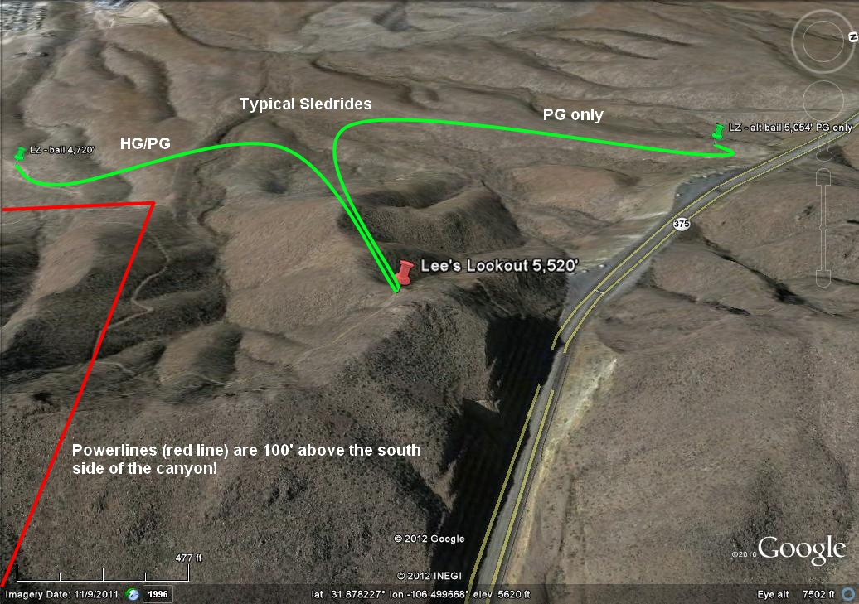

Site hazards and risk management
Launching from this site has two dangers. Be extremely careful of getting sucked into the DM. It is unlikely to happen if you check the wind velocity at the Pass before you hike up. If it's blowing more than 18 at the Pass, be extremely careful when launching – go straight out and keep left of the ridge in front. Better yet, pack up and launch from Agave. If the air at the Pass is less than 18, you are safe no matter where you fly but note that lift disappears at the DM. Landing on the highway is not only illegal but dangerous.
The second danger is the presence of power lines that go east – west along the side of the canyon to the south of launch. They are almost invisible. Make sure that you get a few hundred over launch before you head south and up. In general – STAY AWAY FROM THE SOUTH SIDE OF THE CANYON NEXT TO LAUNCH UNLESS YOU ARE HIGHER THAN THE RIDGE BEHIND. The power lines, fortunately, turn south after leaving the canyon and the poles are easily visible.
View of South Mt. Franklin (Radio Peak) after a successful trip up from Lee's Lookout. You want to smile, too? Fly year 'round in the Franklins with us! From here, this pilot went over 1,000' above the top of the range.
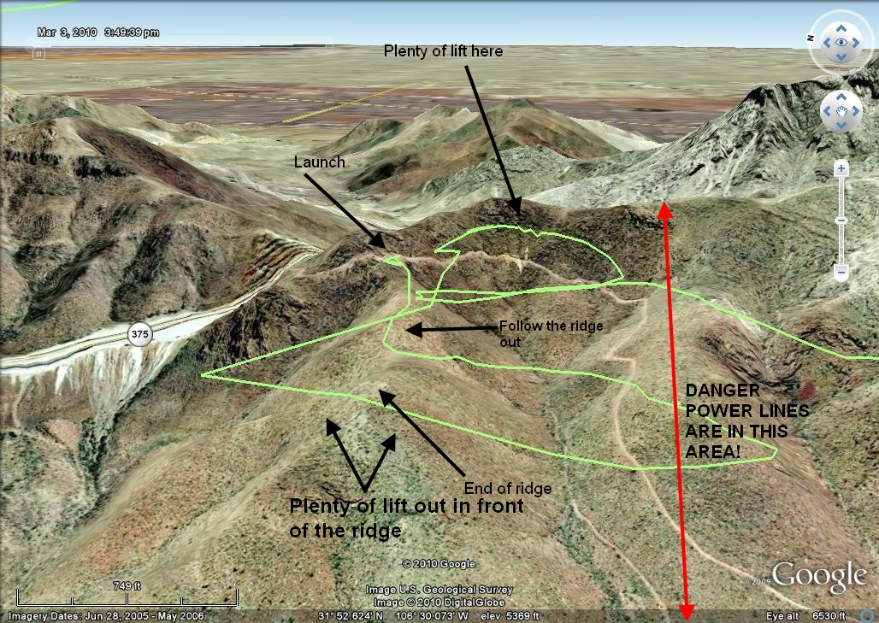
The site's rating (H/P3) is due to the following: 1.) It is a very tight launch area – less than 10 yd. on each side. 2.) There is a sheer cliff just north of launch (good for HG). 3.) You can be blown over the back or sucked into the Dragon's Mouth. 4.) There are numerous desert plants in the vicinity of the launch area that can snag the pilot/glider. (It is a safer HG launch than PG.) Despite these hazards, the site is the best we have for flying in the Franklins. Those who successfully launch are virtually guaranteed to get up and out. The bailout LZ is easily reachable and safe for both HG and PG. Pilots should not fly this site alone because a minor problem at launch could easily cascade. A helper can assist with layout, the inflation of the glider, look for any potential problems, and help the pilot in the event of a failed launch. Expert pilots regularly fail to launch from this site because of its difficulty.
Lee Boone (photo below) is standing about where a PG pilot should launch from. When launching, follow the top of the ridge out. At the end, there is plenty of lift with thermals galore popping off the power lines at the base of the mountain. (The poles can just be seen near the dirt road.) If you launch at the right time of the cycle, you will get in strong lift right at launch and go straight up. You should always turn left, bench up the ridge behind launch, and get high enough to safely pass over the power lines. Follow the ridge south until you get to S. Mt. Franklin and work your way up via thermals and ridge lift. It's an easy task for most pilots. Then you are in the magic airspace above the range and can fly for hours in any direction. Here is info on safely flying in the Franklins once you are above launch.
Below is an image of a typical flight from Lee's Lookout. Most P/H3 pilots should be able to do this without any trouble.
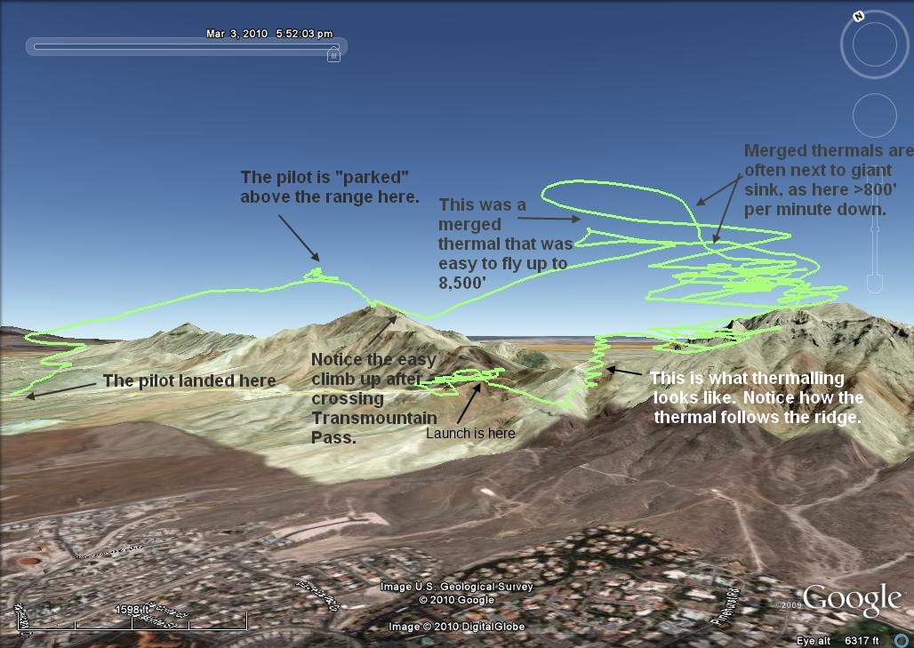

Pilot Registration
You must register with the Park before entering or flying. Solo pilots (not recommended) need to notify the Park Police or a Park Ranger before launching.

